Allegany County Library System
Library Card Application

By completing this application, I agree as a cardholder, parent or guardian to accept full responsibility for all materials selected and borrowed on the account listed below, including any lost or damage fees incurred. I agree to abide by all Library Borrowing Policies
I agree to notify the Library if the card is lost or stolen. Failure to do so will result in my liability for all debts related to the account.
- I will notify the Library of any change in contact information, including address, telephone number or email.
- Library cards expire every 3 years.
I wish to receive notifications via:
- Email
- Text Message (Carrier:____________________)
- Courtesy notifications regarding due dates, overdue items, and available holds will be sent by email and/or text message if provided.
- Accounts may be blocked or barred in accordance with Allegany County Library System policies without notification.

REQUIRED APPLICANT INFORMATION (please print)

FIRST NAME MIDDLE NAME LAST NAME

STREET ADDRESS APARTMENT

CITY STATE ZIP CODE

EMAIL TELEPHONE/CELL

DATE OF BIRTH (MM/DD/YY) PREFERRED PRONOUNS
I certify that the information provided is true and correct to the best of my knowledge.
_____________________________________________________ ______________________
APPLICANT SIGNATURE DATE
Parent/Guardian (required for ages 17 and under)
I hereby accept full responsibility for all materials selected and borrowed on the account listed above, including any lost or damage charges incurred.

Signature _____________________________________________________ Date ______________________________

Print parent/guardian name: ________________________________________________________________________

Library Borrowing Policies
Please read and agree to the following policies:
- I hereby apply for an Allegany County Library Card/Account and agree to abide by all Library policies and regulations.
- I agree to return all library materials that I borrow and make every effort to return them by the due date.
- I understand that only I can use my library card/account.
- I understand I must present my library card or my driver’s license each time I check out materials.
- If I fail to return library materials, I understand that I will receive a bill for the replacement cost and I agree to pay all replacement costs associated with unreturned materials.
- I understand that my library account will be blocked for all borrowing activity if my account balance reaches $20.00.
- I will notify the library of any change of address, telephone number, or email address.
- I understand I am responsible for material borrowed on my lost or stolen library card until the loss is reported to the Library.
- All non-Maryland households will be charged a fee of $10.00 every three years to receive and maintain a library card/account. All minors in the household may receive a library card after the first adult member has paid the $10 fee.
Parent/Guardian Responsibilities:
- Parents and/or guardians may not use their child’s library card/account to use the library and must use their own card/account.
- Parents or guardians are responsible for the use of their child's library card/account.
- If you or your child fails to return library material, the parent/guardian will be responsible for the replacement costs of the materials.
- Upon turning 18, any outstanding replacement charges are transferred to the card holder.
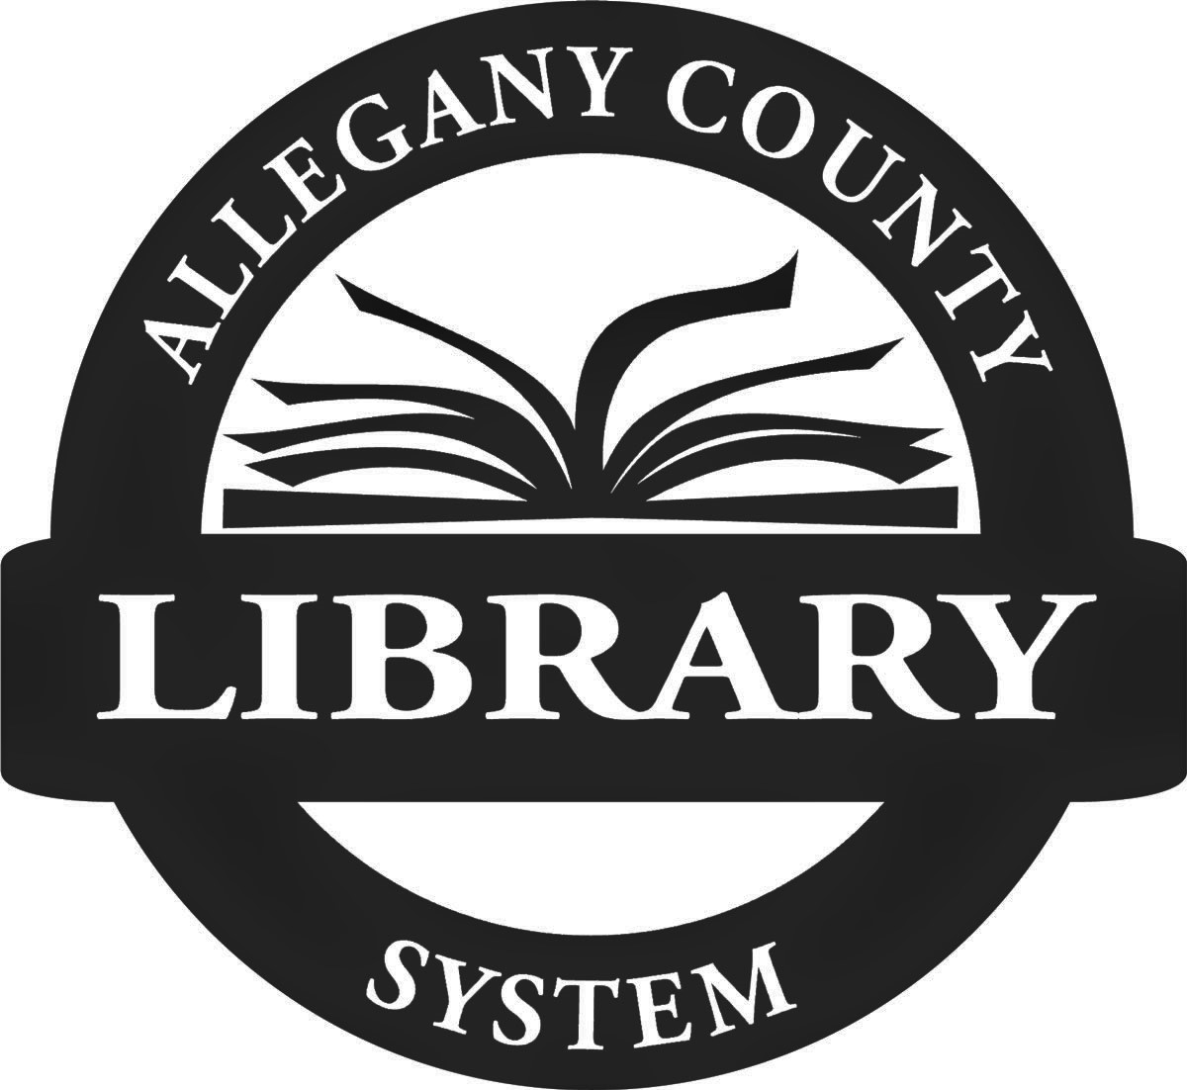
I agree to abide by the Borrowing Policies of the Allegany County Library System, to promptly pay any replacement costs charged to my account, and to give immediate notice of any change of address.

